Classes in the LAW Demo

TemplateWindow

Each exercise view is a subclassed from the TemplateWindow class. The TemplateWindow has the exercise name and file labels, and the submit button. It also contains a TemplateControls view that was to be expanded to be a control bar. It is up to each exercise subclass to override the button delegate methods if necessary and display the contents of the exercise.

Dispatcher

The XML files are handled by the Dispatcher object, which parses the files using the TouchXML API. Since each exercise XML had a set structure, it was easy to retrieve the necessary attributes for each exercise. The attribute information is put into a dictionary, and the appropriate TemplateWindow is created using this dictionary.

AppDelegate
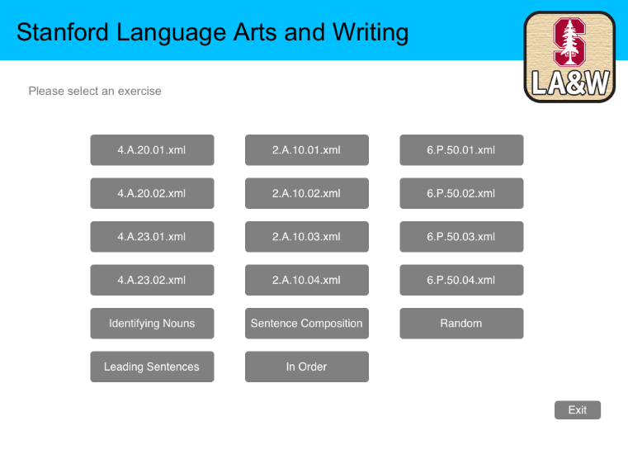
The AppDelegate creates the SelectionMenu, and ultimately feeds a list of XML names to the dispatcher and displays each exercise. It also handles the transition animations of the exercise views.

Intro Screen

SelectionMenu

The selection menu displays each exercise and different sequences of exercises. Tapping any of the buttons will open the selected exercise or start the selected sequence of exercises.

Each button loads either one exercise XML name or a list of exercise XML names for the AppDelegate to create and display.

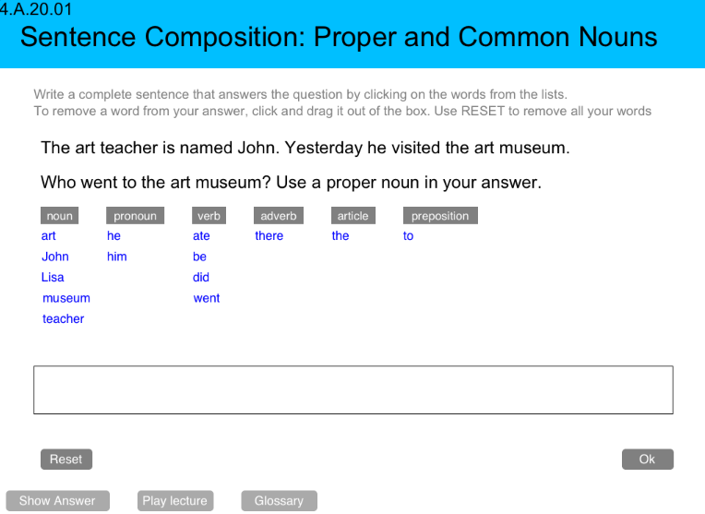
Sentence Composition Exercise

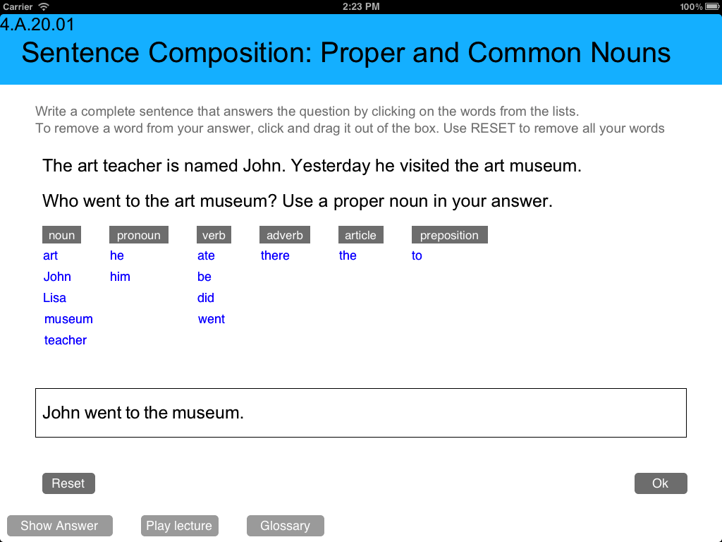
Sentence Composition Exercise

TemplateExperiment

In this exercise, each type of word category is a column of buttons that can be tapped or dragged into the answer box to form a sentence. Words in the answer box can be rearranged by tapping and dragging.

The tappable words are buttons that have target selectors assigned to them. When tapped or dragged, a DraggableWord would appear at the touch point. A DraggableWord is just a UIView that would move with the touch. Since the DraggableWord would appear at the touch position, it would create the illusion that the word itself was being moved. If the touch ends within the bounds of the answer box, then the word would be added to the created sentence. Each time a word is added or moved within the answer box, the words would be redrawn in the right order based on their positions, and lock them into the appropriate position.

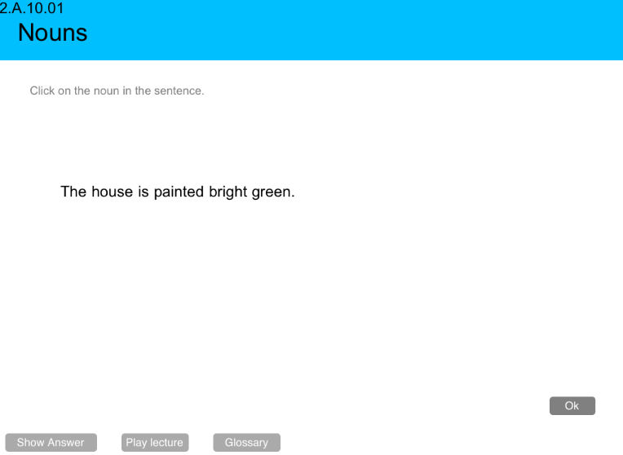
Noun Exercise

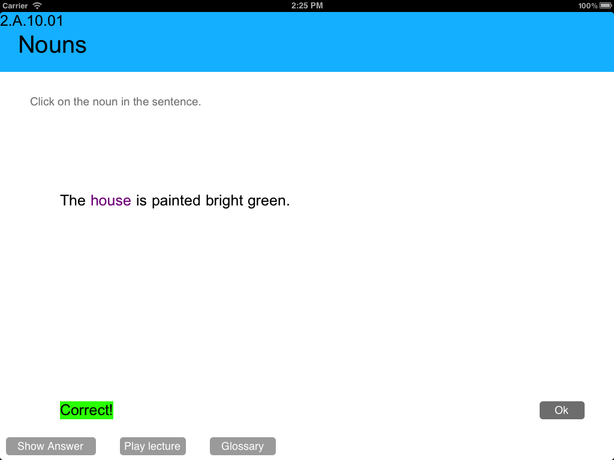
Noun Exercise

TemplateID1

In this exercise, each word can be tapped. When a word is tapped, it has a size animation and the color is changed.

Each word is a label with a gesture recognizer added to it. When the word is tapped, the target selector is called, which performs the animation and color change.

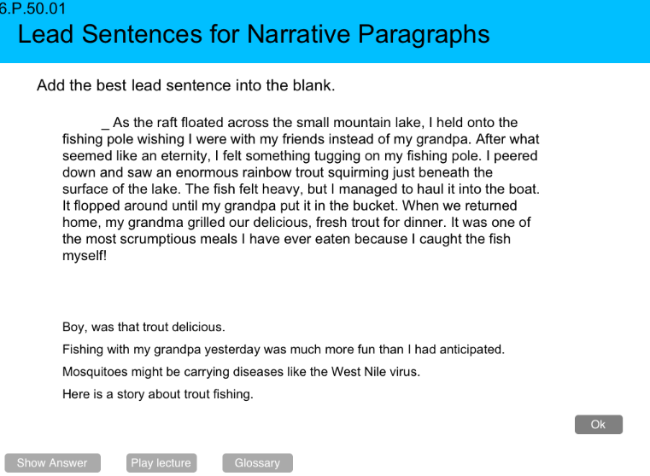
Lead Sentence Exercise

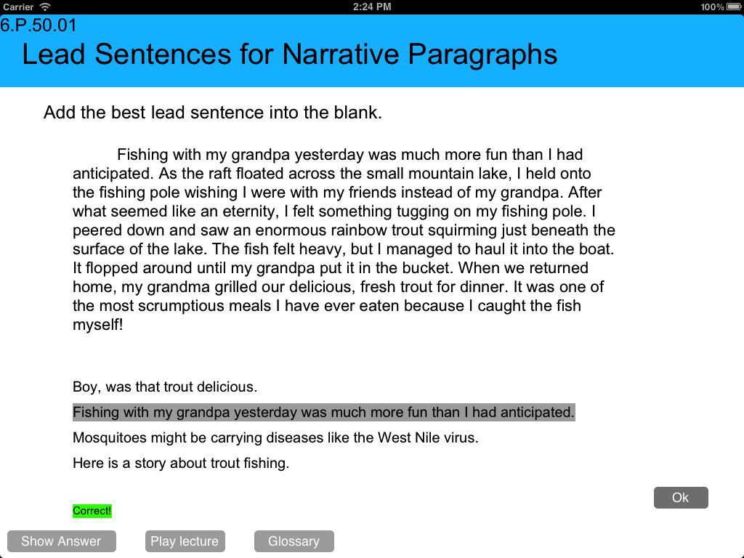
Lead Sentence Exercise

Template32

The lead sentence options can be tapped to add to the beginning of the paragraph in this exercise. Tapping a sentence will swap out the current lead sentence in the paragraph for the tapped one. The tapped sentence will also be highlighted.

Each sentence choice is a button, and tapping the button redraws the paragraph with the selected sentence.

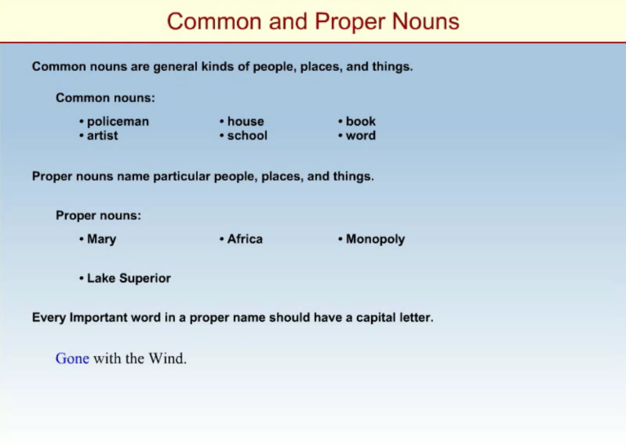
Playing a Lecture

To play the lectures, a MPMoviePlayerViewController is used.

